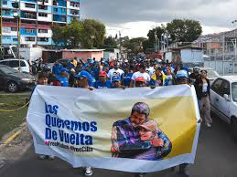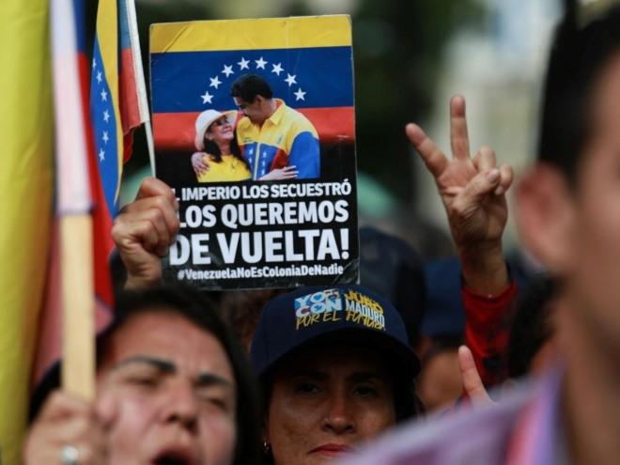
Mobilize for President Maduro's Trial March 26 in Manhattan! Free Venezuela President Nicolas Maduro and Cilia Flores!

We call on all defenders of peace and international law to attend President Maduro and his partner, First Combatant Cilia Flores, trial in NYC March 26. In flagrant violation of international law, the US invaded Venezuela, kidnapped President Maduro and his wife Cilia, and is trying them on fabricated drug trafficking and weapons charges in federal court in Manhattan.
Maduro and Celia Flores are represented by defense attorney Barry Pollack, who previously defended WikiLeaks founder Julian Assange. Venezuela’s Acting President Delcy Rodriquez recently told NBC News that Nicolas Maduro remains Venezuela’s legitimate leader despite his kidnapping by US military on January 3.
The unprecedented significance of President Maduro’s trial is that no International Criminal Court indictment of him exists. Nor is this a trial in international court, as law demands. Rather, the US government is trying the Venezuelan president in US court for alleged violation of US law. A leader of one country cannot be seized, tried, and convicted for violating another country’s laws.
As Nicolás Maduro Guerra, the president’s son, stated before Venezuela’s National Assembly, “If we normalize the kidnapping of a head of state, no country is safe. Today it’s Venezuela. Tomorrow, it could be any nation that refuses to submit.” The US already has created criminal indictments of Venezuela’s Acting President Delcy Rodriguez and of Cuban leaders for violating US law.
The trial of President Maduro and Celia Flores will create an even more dangerous world by its elevating US law above international law, expecting foreign heads of state to comply with US demands or face indictment and armed invasion to seize them. Standing in defense of Nicolas Maduro is not only a defense of Venezuela’s sovereignty but of the sovereignty of all nations.

It is very important to be there due to the strong international media presence covering the event. Our presence at the trial sends a message to Washington that the president of Venezuela and his wife are not alone, and that the world recognizes their human rights have been violated in an unprecedented act in the history of this continent.

Who is Cilia Flores?
Sign the Code Pink statement www.codepink.org/freecilia
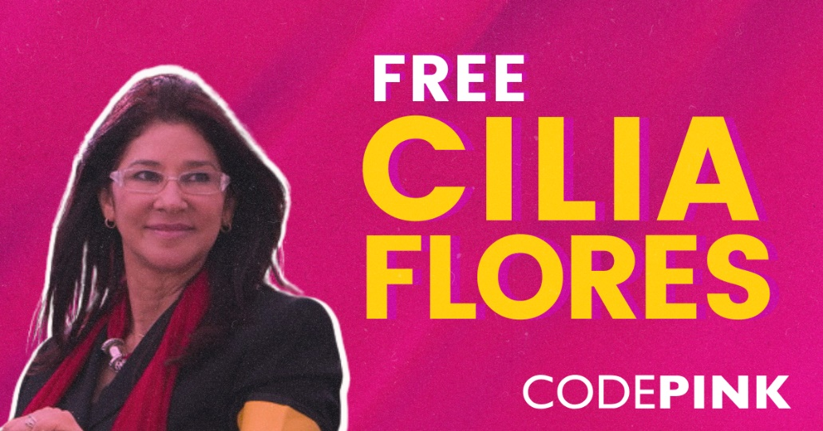
Flores was Hugo Chávez’s lawyer when he was imprisoned in 1992. She later became the first woman to be elected president of Venezuela’s National Assembly, as well as the first woman in the country’s history to be named Solicitor General. She has served multiple terms as a deputy in the National Assembly, having been most recently reelected in 2025.
In Venezuela, women leaders formed the “Cilia Flores for Peace” International Women’s Brigades to build support for Cilia Flores and “defend self-determination and national sovereignty as essentially feminist acts.” Its mission is to “weave a global network of feminist and anti-imperialist solidarity to defend peace, denounce unconventional warfare against the peoples of the Global South, and to specifically support the resistance of Venezuelan and Cuban women.” They are clear that imperialism is an expression of patriarchy and that peace is an act of feminism.

For more information about March 26, contact w.camacaro@hotmail.com or cbalbertolovera@gmail.com

